HUAWEI
TRT-L21C432B140CUSTC432D001
Software Upgrade Guideline

Prepared by | Shravanthi P A S84035704 | Date | 2017-07-07
Reviewed by | Abhijith K S 72191 | Date | 2017-07-07
Approved by | Dinesh R Nayak 70443 | Date | 2017-07-07

Huawei Technologies Co., Ltd.
All rights reserved
Contents
1 Version introduction 3
1.1 The following versions can be upgraded. 3
1.2 Upgrade package 3
2 Upgrade environment requirements 4
2.1 Check current upgrade environment 4
3 Upgrade introduction 5
4 Upgrade operations 5
4.1 Dload package upgrade 5
4.2 Vendor package upgrade 7
4.3 Force upgrade 8
4.4 PASSWORD ERROR 10
5 Upgrade validate 11
5.1 Check the version 11

Version introduction

The following versions can be upgraded.
Versions can be upgraded
TRT-L21C432B100CUSTC432D002
TRT-L21C432B130CUSTC432D001

Upgrade package
Upgrade package | Info
Main package | SDupdate_Package.tar.gz
Vendor package | Test\1.TestSoftware\0_CUSTOM_PACKAGE\hw\eu
Upgrade tools | Micro SD card

Upgrade environment requirements

Check current upgrade environment
- To make sure that the Micro SD card is available and can be read and write.
Notes: A Micro SD card of 8GB or more should be available. It is recommended that The Micro SD card is made by Sandisk, Kingstone, or Kingman.
- To make sure that the power of the battery is enough to run the upgrade process. It is recommended that the power of the battery is more than 30%.
- Upgrade operations will erase all user data. So if there is some important information, you should backup them before upgrade.
- you should unzip the SDupdate_Package.tar.gz file, and the file list is as below:

└─dload
├─ TRT-L21_hw_eu
│ └─update_TRT-L21_hw_eu.app
├─UPDATE.APP
- Vendor package use as shown below in the upgrade file
NOTE: If you face any problem while loading the software about password then refer to this part of the document.

Upgrade introduction
There are two methods to upgrade: normal upgrade and force upgrade.
Normal upgrade needs to start the handset and enter the System Update module. Force upgrade is just used when the handset can’t boot up or can’t enter the idle screen.
Suggest：The whole upgrade contains three steps of update, which applies for both Normal upgrade and force upgrade. The update scheme is shown as follow:
dload upgrade
Vendor package upgrade
dload upgrade

Upgrade operations

Normal Upgrade

Dload package upgrade
- Format the Micro SD card (This operation is optional).
- Copy the entire dload folder (with UPDATE.APP in it) to the root directory of the Micro SD card. Check if the whole file list in sdcard,
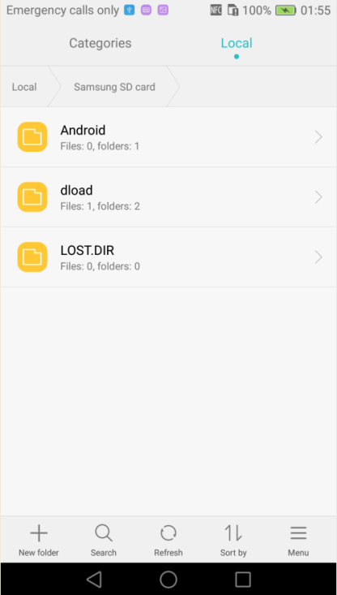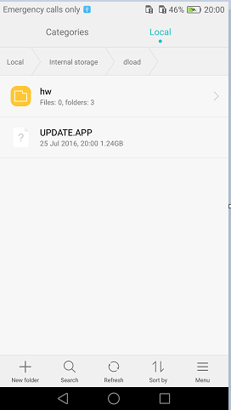
Insert the Micro SD card into the handset and power on. After entering call -> enter:*#*#2846579#*#* -> Project Menu -> Software Upgrade -> SDCard Upgrade-> OK，
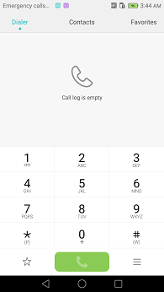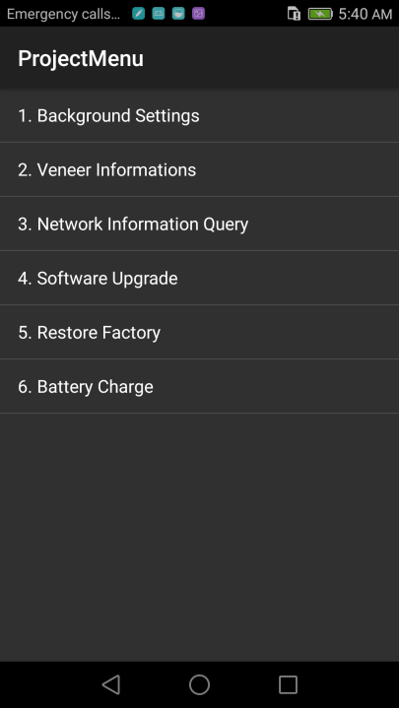

- When the progress bar stop, the phone will restart automatically.
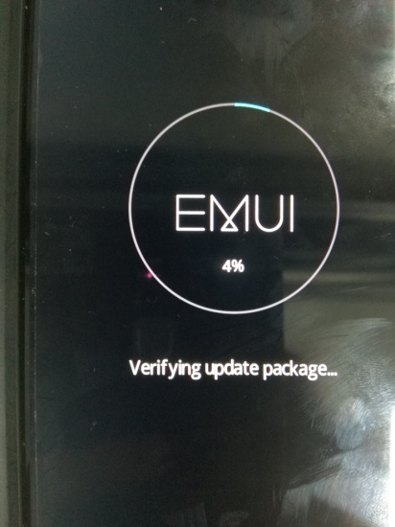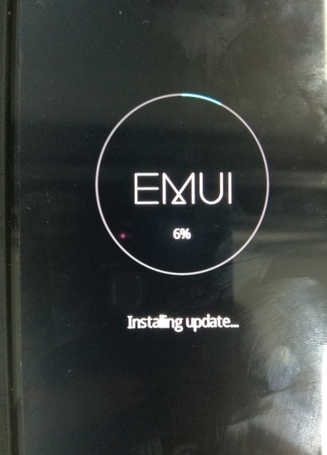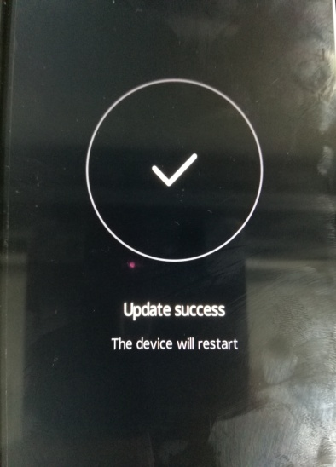

4.1.2 Vendor package upgrade
- Format the Micro SD card (This operation is optional).
- Copy the entire dload folder from the vendor to the root directory of the Micro SD card . Check if the whole file list in sdcard,

Insert the Micro SD card into the handset and power on. After entering call -> enter:*#*#2846579#*#* -> Project Menu -> Software Upgrade -> SDCard Upgrade-> OK，

- When the progress bar stop, the phone will restart automatically.

- Manually restore the factory settings
Settings -> Advanced settings ->Backup & reset ->Factory data reset ->Reset phone ->Reset phone

: Dload package upgrade again
Step1. Repeat steps 4.1.1 to ensure your DUT update success again

Force upgrade
Attention:
This step is optional. If the Normal upgrade is not successful, then you can use this upgrade instead of the normal upgrade!

- Format the Micro SD card (This operation is optional).
- Copy the entire dload folder (with UPDATE.APP in it) to the root directory of the Micro SD card. Check the file list is right.
- Make sure your handset is power off. Insert the Micro SD card into the handset. Press the VOLUME UP and VOLUME DOWN key, and then press the POWER key to power on the phone and enter the Software Upgrade Mode.
- When the progress bar stop, the phone will restart automatically.

Upgrade validate

Check the version
      - By step: Settings->about phone->Build number, to check the version is correct or not.

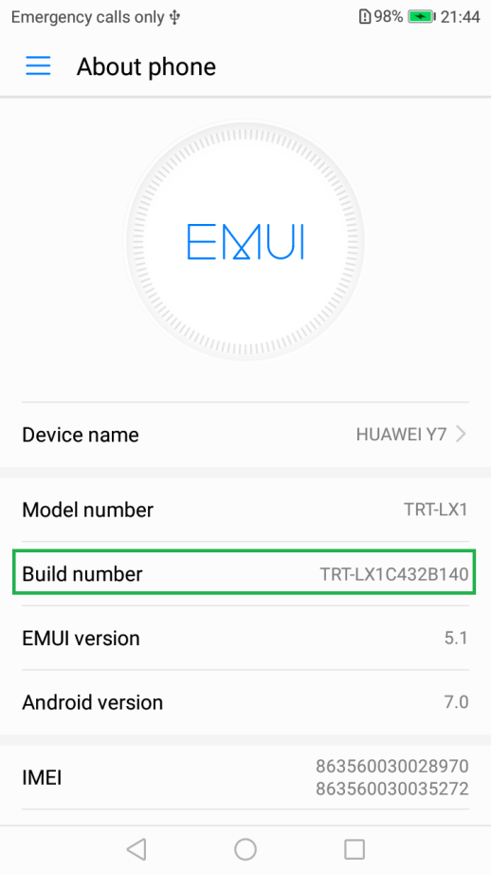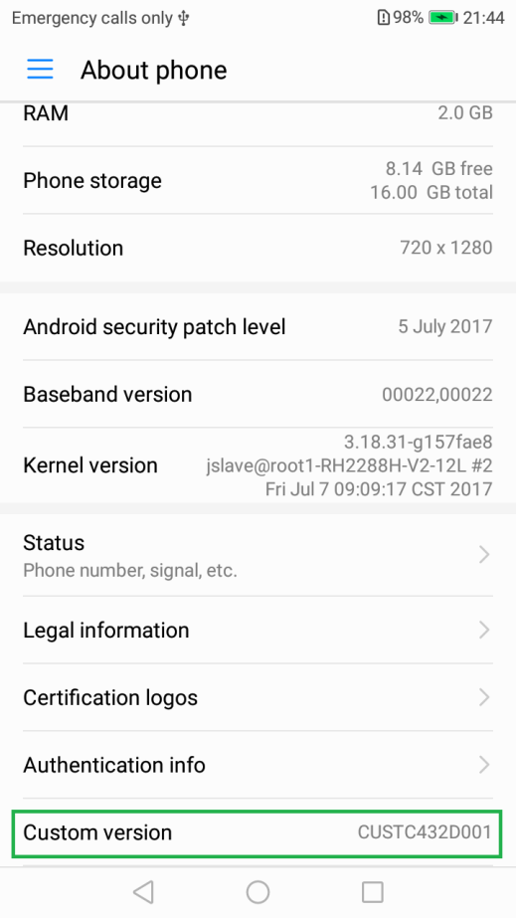
Build number: TRT-L21C432B140
Custom: CUSTC432D001
Note: - Images are only for reference purpose. Actual phone screen may not match with reference images.

